Fly Away Plus

Detail Design Document

Class Design

Project Code:

Document Code:

Record of Change

|  |  |  |  |  |
| --- | --- | --- | --- | --- |
|  |  |  |  |  |

Signature Page

Table of Content

# Introduction

## Purpose

Fly Away Plus class design document contains descriptions of all classes of the Fly Away Plus. It includes:

* Class diagrams that describe the static relation of all classes in the system.

## Definitions, Acronyms and Abbreviations

|  |  |  |
| --- | --- | --- |
|  |  |  |
| FAQ | Frequently Asked Question |  |

# Packages

|  |  |  |  |
| --- | --- | --- | --- |
| No. | Packages | Language | Description |
|  | Search | C# |  |
|  | Help Center |  | Contain help content, FAQ and using guides |
|  | Suggest | C# | Create suggestion based on user activities history |
|  | Personal Page |  | Contain user’s personal page: New feed, Timeline, Post, … |
|  | Post Management |  | Contain information and data which related to posts |
|  | Share Management |  | Share FAP contents to other social networks |
|  | Comment Management |  | Contain information of comments |
|  | Like Management |  |  |
|  | Report |  |  |
|  | Chat |  |  |
|  | Friend Management |  |  |
|  | Room |  |  |
|  | Login |  |  |
|  | Manage Member’s Account |  |  |
|  |  |  |  |

## Search

### Class Diagram

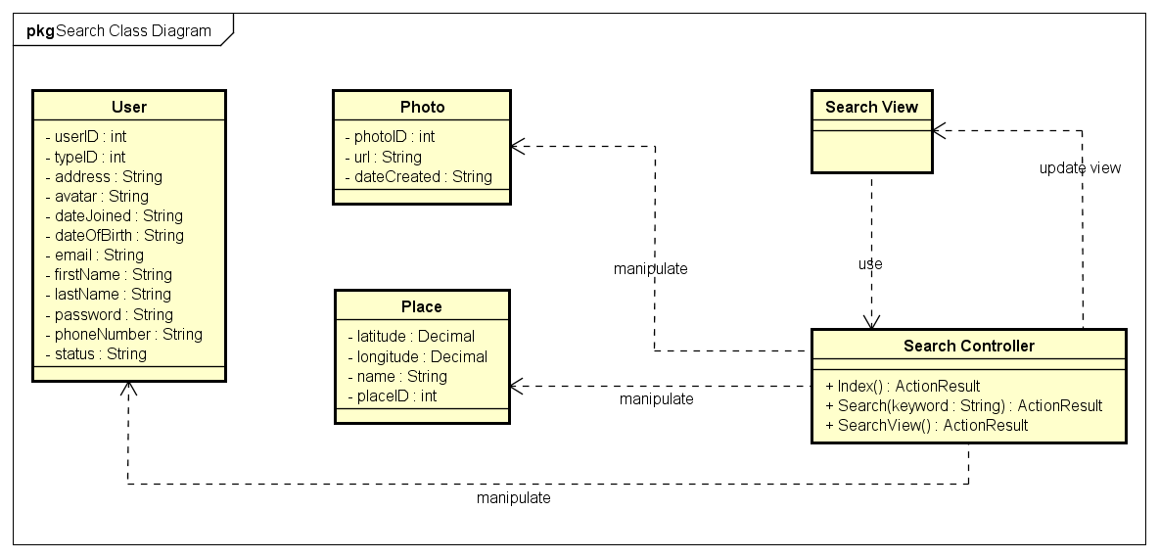

|  |  |  |
| --- | --- | --- |
| No. | Class Name | Description |
|  | User | Include method interact with Database |
|  | Photo | Include method interact with Database |
|  | Place | Include method interact with Database |
|  | Search | Include method interact with Controller |
|  | Search Controller | Include method interact with Model |

### User Class

#### Attributes

|  |  |  |  |  |  |
| --- | --- | --- | --- | --- | --- |
| No | Attributes | Type | Default | Note | Description |
|  | userID | int |  | public |  |
|  | typeID | int |  | public |  |
|  | address | String |  | public |  |
|  | avatar | String |  | public |  |
|  | dateJoined | String |  | public |  |
|  | dateOfBirth | String |  | public |  |
|  | email | String |  | public |  |
|  | firstName | String |  | public |  |
|  | lastName | String |  | public |  |
|  | password | String |  | public |  |
|  | phoneNumber | String |  | public |  |
|  | status | String |  | public |  |

#### Methods

|  |  |  |  |  |
| --- | --- | --- | --- | --- |
| No. | Method | Input | Return | Description |
|  |  |  |  |  |

### Photo Class

#### Attributes

|  |  |  |  |  |  |
| --- | --- | --- | --- | --- | --- |
| No | Attributes | Type | Default | Note | Description |
|  | photoID | int |  |  |  |
|  | url | String |  |  |  |
|  | dateCreated | String |  |  |  |

#### Methods

|  |  |  |  |  |
| --- | --- | --- | --- | --- |
| No. | Method | Input | Return | Description |
|  |  |  |  |  |

### Place Class

#### Attributes

|  |  |  |  |  |  |
| --- | --- | --- | --- | --- | --- |
| No | Attributes | Type | Default | Note | Description |
|  | placeID | int |  |  |  |
|  | name | String |  |  |  |
|  | latitude | Decimal |  |  |  |
|  | longitude | Decimal |  |  |  |

#### Methods

|  |  |  |  |  |
| --- | --- | --- | --- | --- |
| No. | Method | Input | Return | Description |
|  |  |  |  |  |

### SearchController class

#### Attributes

|  |  |  |  |  |  |
| --- | --- | --- | --- | --- | --- |
| No | Attributes | Type | Default | Note | Description |
|  |  |  |  |  |  |

#### Methods

|  |  |  |  |  |
| --- | --- | --- | --- | --- |
| No. | Method | Input | Return | Description |
|  | Index |  | ActionResult | Display Search page |
|  | Search | String | ActionResult | Search a keyword |
|  | SearchDetail |  | ActionResult | Display Search Result page |

### Sequence Diagram

#### UC001-Search by name

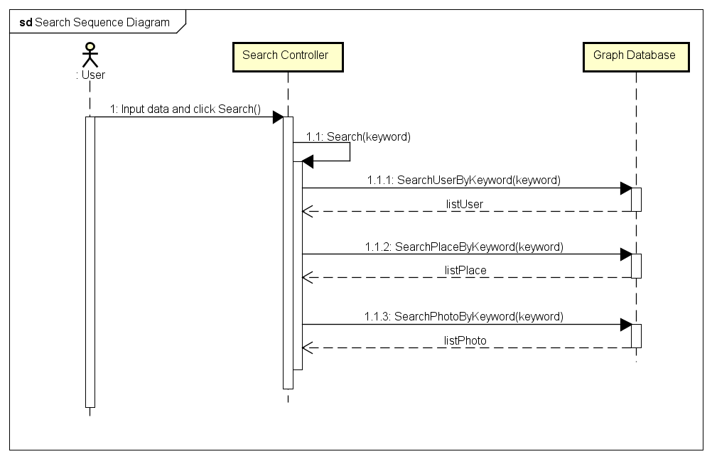

## Help Center (Undone)

## Suggest (Undone)

## Post Management

### Class Diagram

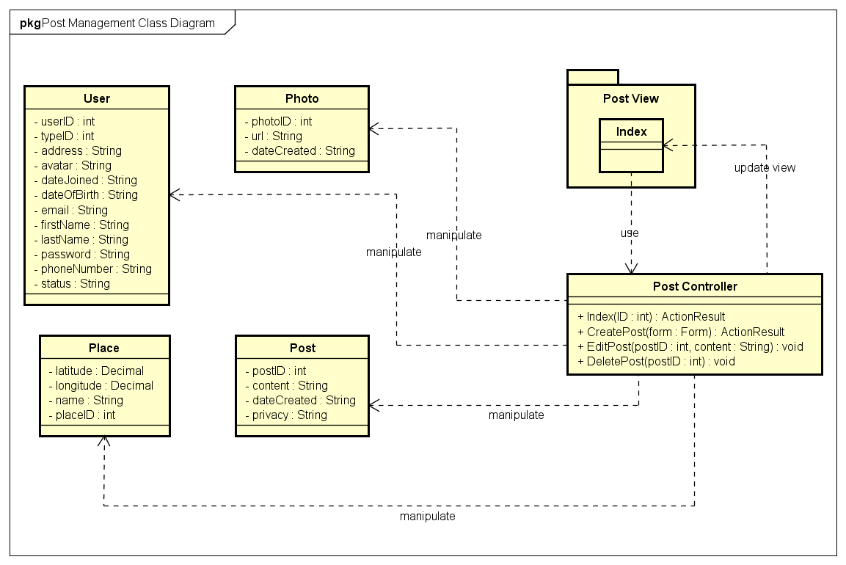

|  |  |  |
| --- | --- | --- |
| No. | Class Name | Description |
|  | User | Include method interact with Database |
|  | Photo | Include method interact with Database |
|  | Place | Include method interact with Database |
|  | Index | Include method interact with Controller |
|  | Post Controller | Include method interact with Model |

### User Class

#### Attributes

|  |  |  |  |  |  |
| --- | --- | --- | --- | --- | --- |
| No | Attributes | Type | Default | Note | Description |
|  | userID | int |  | public |  |
|  | typeID | int |  | public |  |
|  | address | String |  | public |  |
|  | avatar | String |  | public |  |
|  | dateJoined | String |  | public |  |
|  | dateOfBirth | String |  | public |  |
|  | email | String |  | public |  |
|  | firstName | String |  | public |  |
|  | lastName | String |  | public |  |
|  | password | String |  | public |  |
|  | phoneNumber | String |  | public |  |
|  | status | String |  | public |  |

#### Methods

|  |  |  |  |  |
| --- | --- | --- | --- | --- |
| No. | Method | Input | Return | Description |
|  |  |  |  |  |

### Photo Class

#### Attributes

|  |  |  |  |  |  |
| --- | --- | --- | --- | --- | --- |
| No | Attributes | Type | Default | Note | Description |
|  | photoID | int |  |  |  |
|  | url | String |  |  |  |
|  | dateCreated | String |  |  |  |

#### Methods

|  |  |  |  |  |
| --- | --- | --- | --- | --- |
| No. | Method | Input | Return | Description |
|  |  |  |  |  |

### Place Class

#### Attributes

|  |  |  |  |  |  |
| --- | --- | --- | --- | --- | --- |
| No | Attributes | Type | Default | Note | Description |
|  | placeID | int |  |  |  |
|  | name | String |  |  |  |
|  | latitude | Decimal |  |  |  |
|  | longitude | Decimal |  |  |  |

#### Methods

|  |  |  |  |  |
| --- | --- | --- | --- | --- |
| No. | Method | Input | Return | Description |
|  |  |  |  |  |

### Post Class

#### Attributes

|  |  |  |  |  |  |
| --- | --- | --- | --- | --- | --- |
| No | Attributes | Type | Default | Note | Description |
|  | postID | int |  |  |  |
|  | content | String |  |  |  |
|  | dateCreated | String |  |  |  |
|  | privacy | String |  |  |  |

#### Methods

|  |  |  |  |  |
| --- | --- | --- | --- | --- |
| No. | Method | Input | Return | Description |
|  |  |  |  |  |

### Post Controller Class

#### Attributes

|  |  |  |  |  |  |
| --- | --- | --- | --- | --- | --- |
| No | Attributes | Type | Default | Note | Description |
|  |  |  |  |  |  |

#### Methods

|  |  |  |  |  |
| --- | --- | --- | --- | --- |
| No. | Method | Input | Return | Description |
|  | Index |  | ActionResult | Display Search page |
|  | Search | String | ActionResult | Search a keyword |
|  | SearchDetail |  | ActionResult | Display Search Result page |

### Sequence Diagram

#### Add Post

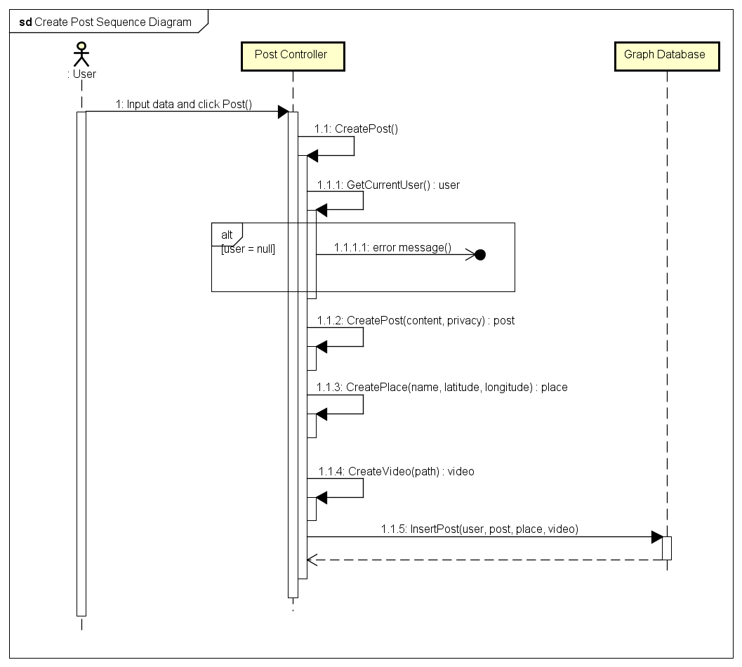

#### Edit Post

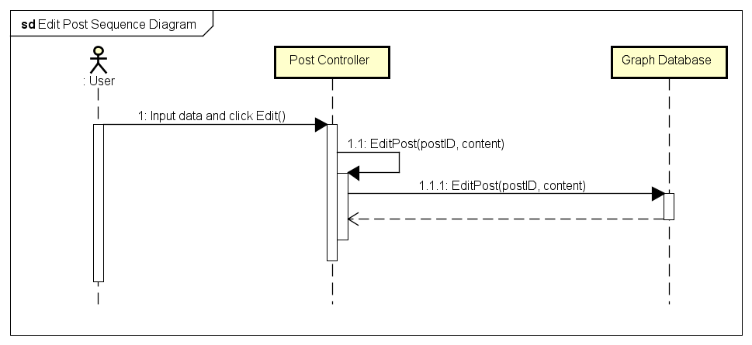

#### Delete Post

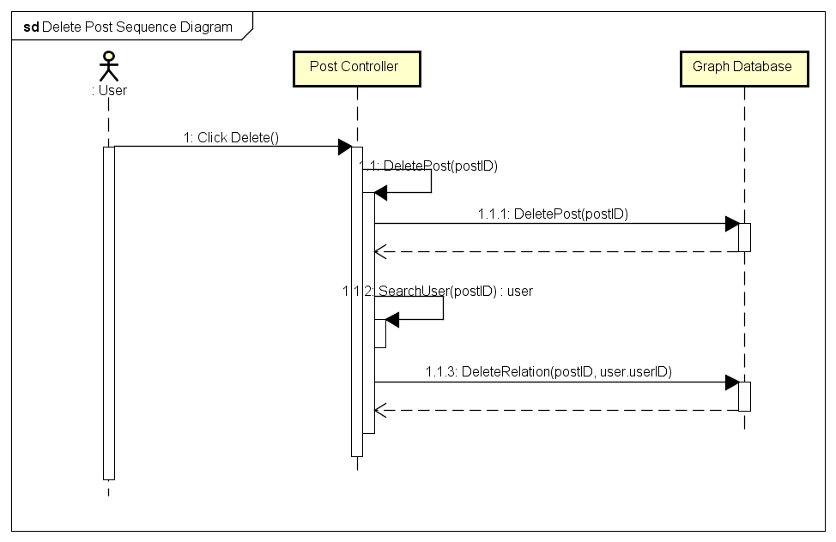

## Share Management (Undone)

## Comment Management

### Class Diagram

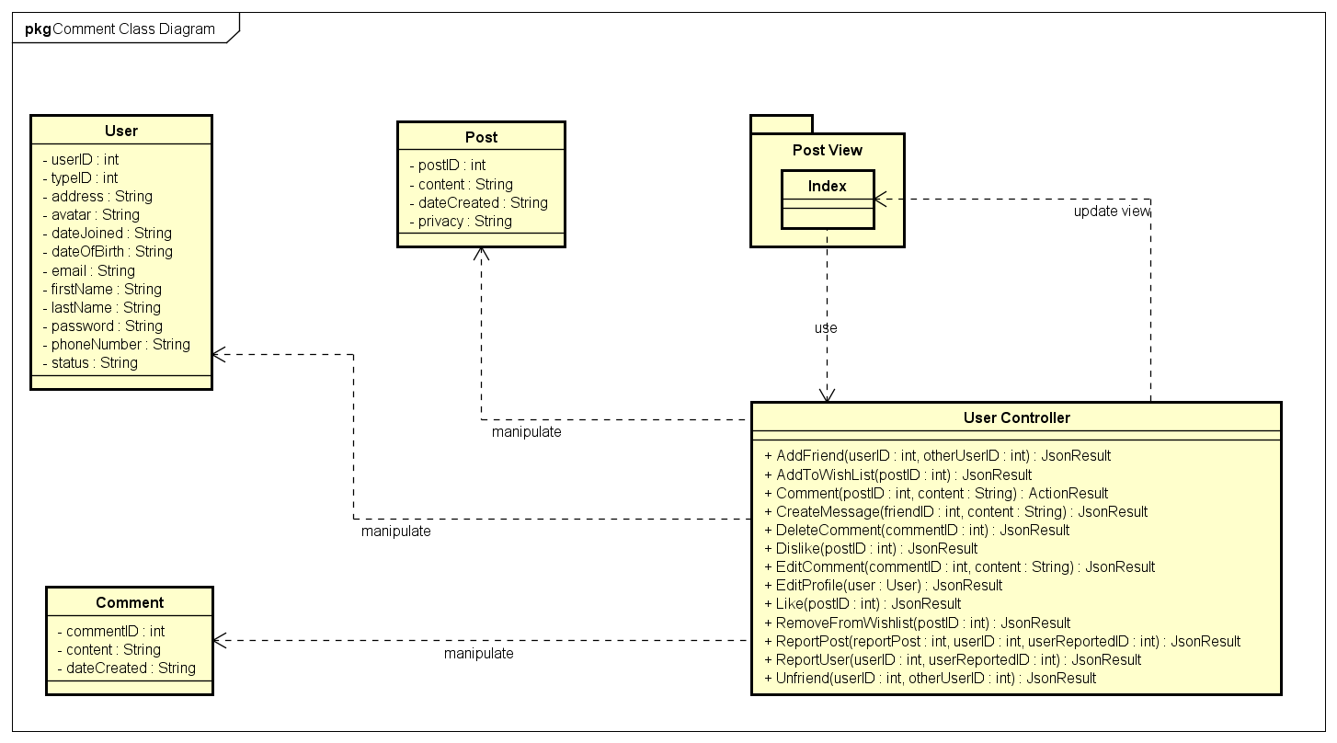

|  |  |  |
| --- | --- | --- |
| No. | Class Name | Description |
|  | User | Include method interact with Database |
|  | Post | Include method interact with Database |
|  | Comment | Include method interact with Database |
|  | Index | Include method interact with Controller |
|  | User Controller | Include method interact with Model |

### User Class

#### Attributes

|  |  |  |  |  |  |
| --- | --- | --- | --- | --- | --- |
| No | Attributes | Type | Default | Note | Description |
|  | userID | int |  | public |  |
|  | typeID | int |  | public |  |
|  | address | String |  | public |  |
|  | avatar | String |  | public |  |
|  | dateJoined | String |  | public |  |
|  | dateOfBirth | String |  | public |  |
|  | email | String |  | public |  |
|  | firstName | String |  | public |  |
|  | lastName | String |  | public |  |
|  | password | String |  | public |  |
|  | phoneNumber | String |  | public |  |
|  | status | String |  | public |  |

#### Methods

|  |  |  |  |  |
| --- | --- | --- | --- | --- |
| No. | Method | Input | Return | Description |
|  |  |  |  |  |

### Post Class

#### Attributes

|  |  |  |  |  |  |
| --- | --- | --- | --- | --- | --- |
| No | Attributes | Type | Default | Note | Description |
|  | postID | int |  |  |  |
|  | content | String |  |  |  |
|  | dateCreated | String |  |  |  |
|  | privacy | String |  |  |  |

#### Methods

|  |  |  |  |  |
| --- | --- | --- | --- | --- |
| No. | Method | Input | Return | Description |
|  |  |  |  |  |

### User Controller Class

#### Attributes

|  |  |  |  |  |  |
| --- | --- | --- | --- | --- | --- |
| No | Attributes | Type | Default | Note | Description |
|  |  |  |  |  |  |

#### Methods

|  |  |  |  |  |
| --- | --- | --- | --- | --- |
| No. | Method | Input | Return | Description |
|  | AddFriend | int, int | JsonResult | Add other users to friend list to get news, notification and messages |
|  | AddToWishlist | String | JsonResult | Add a post to wish list |
|  | Comment | int, String | ActionResult | Create a comment |
|  | CreateMessage | int, String | JsonResult | Send message to others |
|  | DeleteComment | int | JsonResult | Delete an owned comment |
|  | Dislike | int | JsonResult | Mark a post as dislike |
|  | EditComment | int, String | JsonResult | Edit content of an owned comment |
|  | EditProfile | user | JsonResult | Edit personal information |
|  | Like | int | JsonResult | Mark a post as liked |
|  | RemoveFromWishlist | int | JsonResult | Remove a post from wish list |
|  | ReportPost | int, int, int | JsonResult | Report a rule violation post |
|  | ReportUser | int, int | JsonResult | Report a rule violation user |
|  | Unfriend | int, int | JsonResult | Remove an user from friend list |

### Sequence Diagram

#### Add Comment



#### Edit Comment

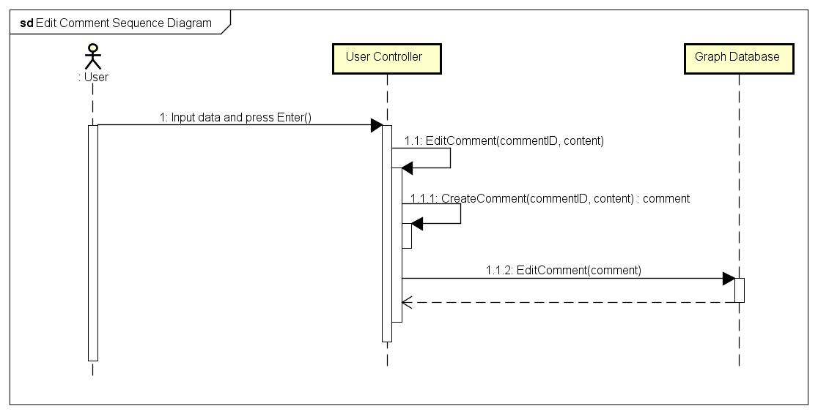

#### Delete Comment

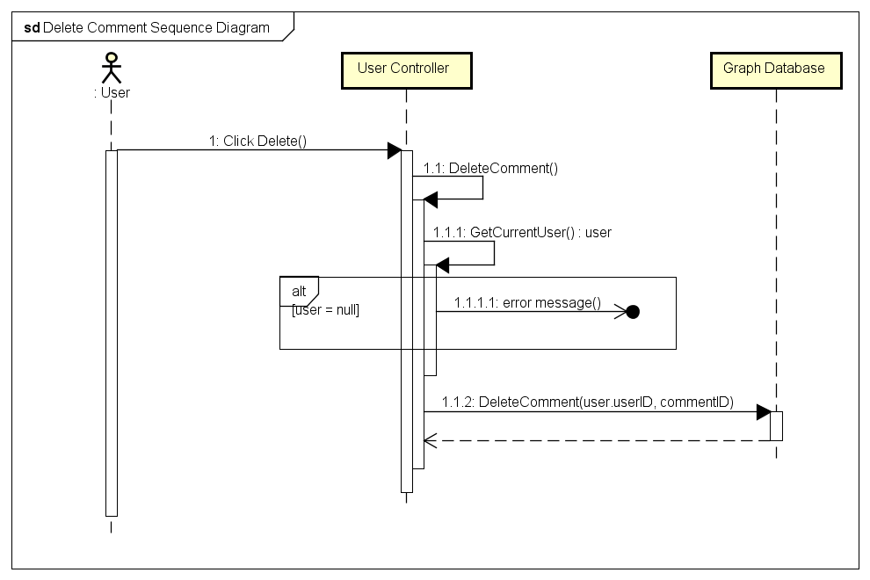

## Like Management

### Class Diagram

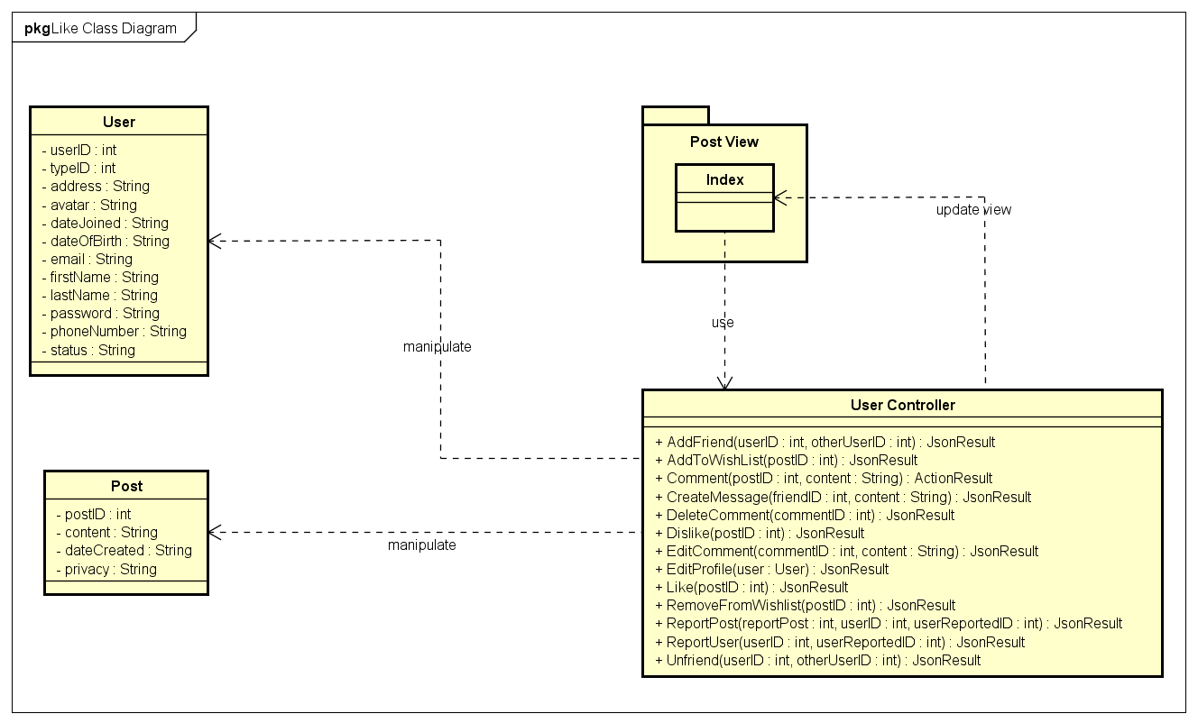

|  |  |  |
| --- | --- | --- |
| No. | Class Name | Description |
|  | User | Include method interact with Database |
|  | Post | Include method interact with Database |
|  | Index | Include method interact with Controller |
|  | User Controller | Include method interact with Model |

### User Class

#### Attributes

|  |  |  |  |  |  |
| --- | --- | --- | --- | --- | --- |
| No | Attributes | Type | Default | Note | Description |
|  | userID | int |  | public |  |
|  | typeID | int |  | public |  |
|  | address | String |  | public |  |
|  | avatar | String |  | public |  |
|  | dateJoined | String |  | public |  |
|  | dateOfBirth | String |  | public |  |
|  | email | String |  | public |  |
|  | firstName | String |  | public |  |
|  | lastName | String |  | public |  |
|  | password | String |  | public |  |
|  | phoneNumber | String |  | public |  |
|  | status | String |  | public |  |

#### Methods

|  |  |  |  |  |
| --- | --- | --- | --- | --- |
| No. | Method | Input | Return | Description |
|  |  |  |  |  |

### Post Class

#### Attributes

|  |  |  |  |  |  |
| --- | --- | --- | --- | --- | --- |
| No | Attributes | Type | Default | Note | Description |
|  | postID | int |  |  |  |
|  | content | String |  |  |  |
|  | dateCreated | String |  |  |  |
|  | privacy | String |  |  |  |

#### Methods

|  |  |  |  |  |
| --- | --- | --- | --- | --- |
| No. | Method | Input | Return | Description |
|  |  |  |  |  |

### User Controller Class

#### Attributes

|  |  |  |  |  |  |
| --- | --- | --- | --- | --- | --- |
| No | Attributes | Type | Default | Note | Description |
|  |  |  |  |  |  |

#### Methods

|  |  |  |  |  |
| --- | --- | --- | --- | --- |
| No. | Method | Input | Return | Description |
|  | AddFriend | int, int | JsonResult | Add other users to friend list to get news, notification and messages |
|  | AddToWishlist | String | JsonResult | Add a post to wish list |
|  | Comment | int, String | ActionResult | Create a comment |
|  | CreateMessage | int, String | JsonResult | Send message to others |
|  | DeleteComment | int | JsonResult | Delete an owned comment |
|  | Dislike | int | JsonResult | Mark a post as dislike |
|  | EditComment | int, String | JsonResult | Edit content of an owned comment |
|  | EditProfile | user | JsonResult | Edit personal information |
|  | Like | int | JsonResult | Mark a post as liked |
|  | RemoveFromWishlist | int | JsonResult | Remove a post from wish list |
|  | ReportPost | int, int, int | JsonResult | Report a rule violation post |
|  | ReportUser | int, int | JsonResult | Report a rule violation user |
|  | Unfriend | int, int | JsonResult | Remove an user from friend list |

### Sequence Diagram

#### Like

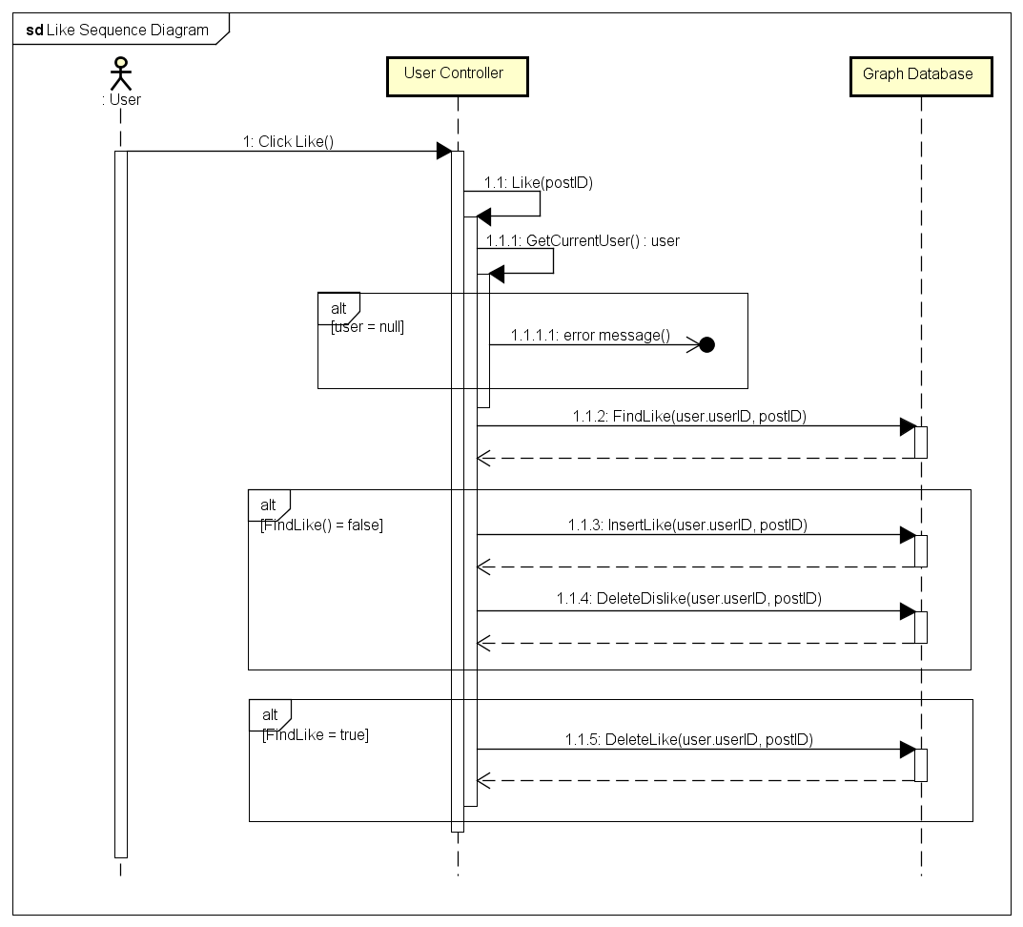

#### Dislike

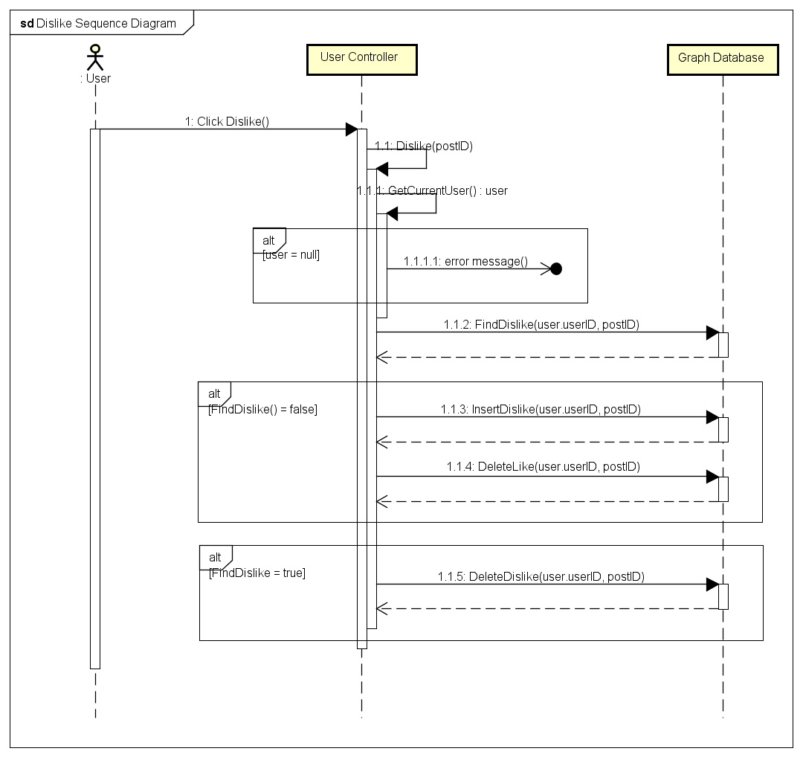

## Report

### Class Diagram

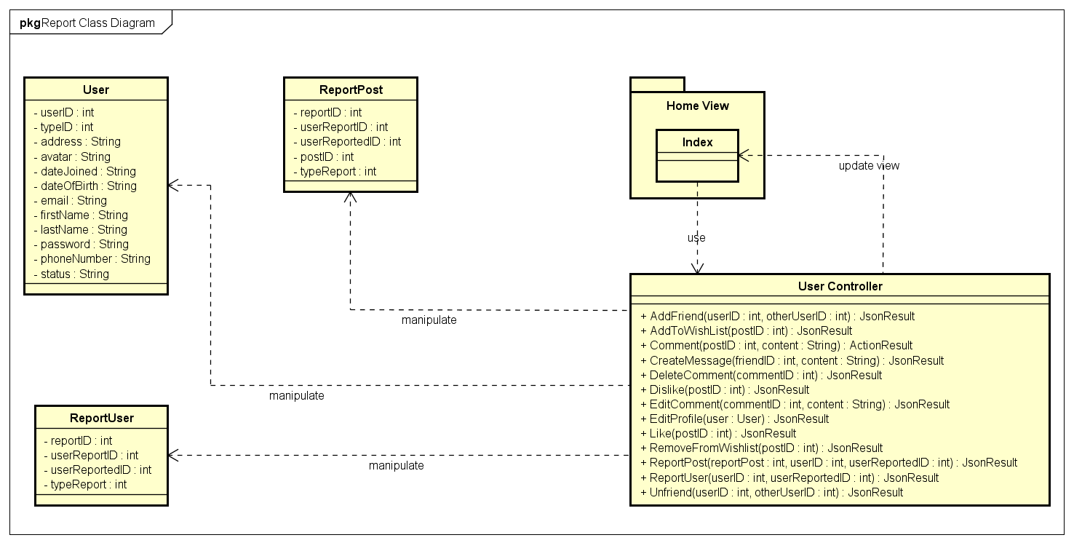

|  |  |  |
| --- | --- | --- |
| No. | Class Name | Description |
|  | User | Include method interact with Database |
|  | ReportPost | Include method interact with Database |
|  | ReportUser | Include method interact with Database |
|  | Index | Include method interact with Controller |
|  | User Controller | Include method interact with Model |

### User Class

#### Attributes

|  |  |  |  |  |  |
| --- | --- | --- | --- | --- | --- |
| No | Attributes | Type | Default | Note | Description |
|  | userID | int |  | public |  |
|  | typeID | int |  | public |  |
|  | address | String |  | public |  |
|  | avatar | String |  | public |  |
|  | dateJoined | String |  | public |  |
|  | dateOfBirth | String |  | public |  |
|  | email | String |  | public |  |
|  | firstName | String |  | public |  |
|  | lastName | String |  | public |  |
|  | password | String |  | public |  |
|  | phoneNumber | String |  | public |  |
|  | status | String |  | public |  |

#### Methods

|  |  |  |  |  |
| --- | --- | --- | --- | --- |
| No. | Method | Input | Return | Description |
|  |  |  |  |  |

### ReportPost Class

#### Attributes

|  |  |  |  |  |  |
| --- | --- | --- | --- | --- | --- |
| No | Attributes | Type | Default | Note | Description |
|  | reportID | int |  | public |  |
|  | userReportID | int |  | public |  |
|  | userReportedID | int |  | public |  |
|  | postID | int |  | public |  |
|  | typeReport | int |  | public |  |

#### Methods

|  |  |  |  |  |
| --- | --- | --- | --- | --- |
| No. | Method | Input | Return | Description |
|  |  |  |  |  |

### ReportUser Class

#### Attributes

|  |  |  |  |  |  |
| --- | --- | --- | --- | --- | --- |
| No | Attributes | Type | Default | Note | Description |
|  | reportID | int |  | public |  |
|  | userReportID | int |  | public |  |
|  | userReportedID | int |  | public |  |
|  | typeReport | int |  | public |  |

#### Methods

|  |  |  |  |  |
| --- | --- | --- | --- | --- |
| No. | Method | Input | Return | Description |
|  |  |  |  |  |

### Sequence Diagram

#### Report a post

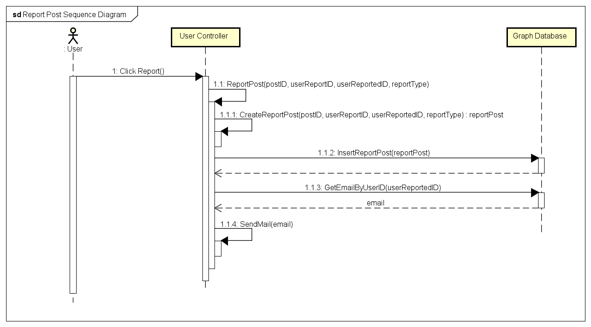

#### Report an user

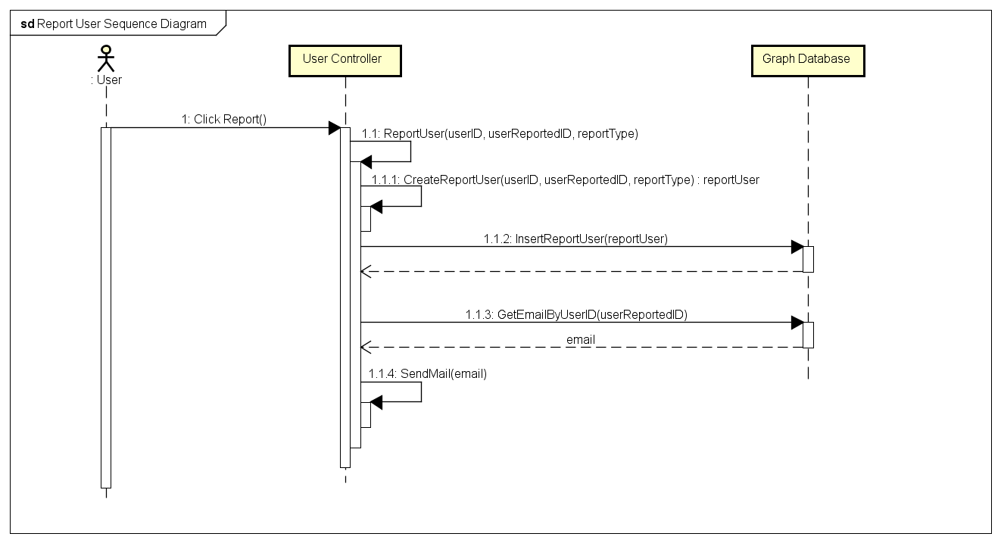

## Chat

### Class Diagram

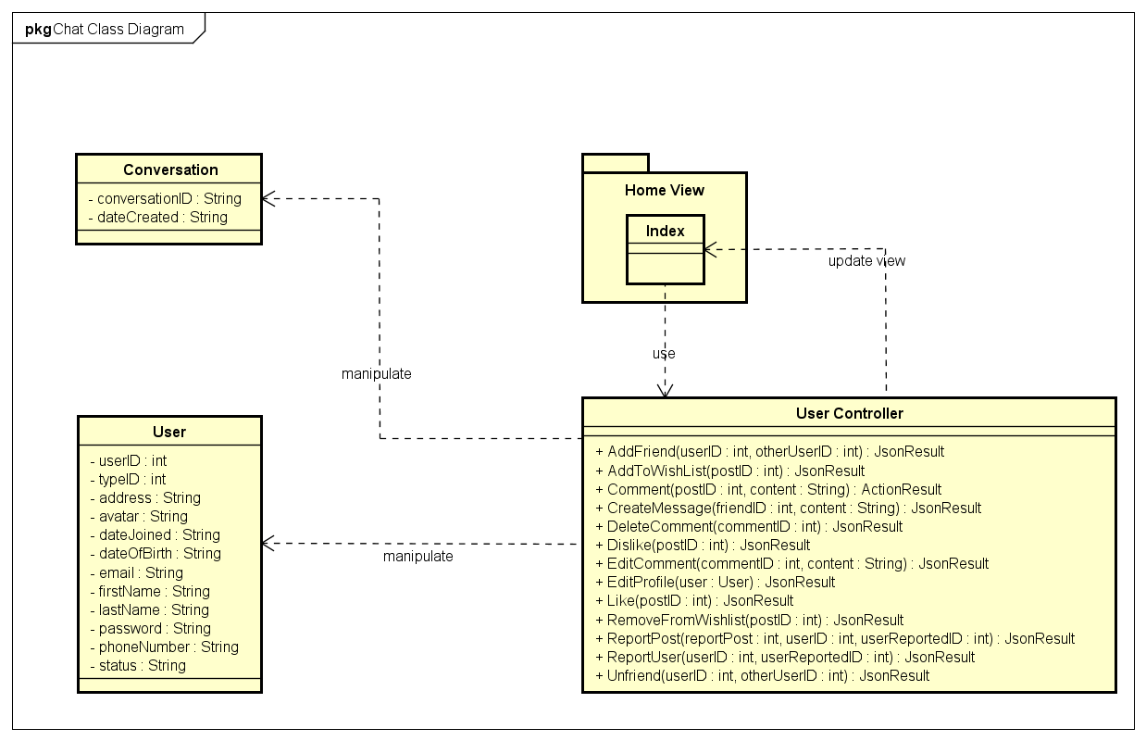

|  |  |  |
| --- | --- | --- |
| No. | Class Name | Description |
|  | User | Include method interact with Database |
|  | ReportPost | Include method interact with Database |
|  | ReportUser | Include method interact with Database |
|  | Index | Include method interact with Controller |
|  | User Controller | Include method interact with Model |

### User Class

#### Attributes

|  |  |  |  |  |  |
| --- | --- | --- | --- | --- | --- |
| No | Attributes | Type | Default | Note | Description |
|  | userID | int |  | public |  |
|  | typeID | int |  | public |  |
|  | address | String |  | public |  |
|  | avatar | String |  | public |  |
|  | dateJoined | String |  | public |  |
|  | dateOfBirth | String |  | public |  |
|  | email | String |  | public |  |
|  | firstName | String |  | public |  |
|  | lastName | String |  | public |  |
|  | password | String |  | public |  |
|  | phoneNumber | String |  | public |  |
|  | status | String |  | public |  |

#### Methods

|  |  |  |  |  |
| --- | --- | --- | --- | --- |
| No. | Method | Input | Return | Description |
|  |  |  |  |  |

### Conversation Class

#### Attributes

|  |  |  |  |  |  |
| --- | --- | --- | --- | --- | --- |
| No | Attributes | Type | Default | Note | Description |
|  | conversationID | String |  | public |  |
|  | dateCreated | String |  | public |  |

#### Methods

|  |  |  |  |  |
| --- | --- | --- | --- | --- |
| No. | Method | Input | Return | Description |
|  |  |  |  |  |

### User Controller Class

#### Attributes

|  |  |  |  |  |  |
| --- | --- | --- | --- | --- | --- |
| No | Attributes | Type | Default | Note | Description |
|  |  |  |  |  |  |

#### Methods

|  |  |  |  |  |
| --- | --- | --- | --- | --- |
| No. | Method | Input | Return | Description |
|  | AddFriend | int, int | JsonResult | Add other users to friend list to get news, notification and messages |
|  | AddToWishlist | String | JsonResult | Add a post to wish list |
|  | Comment | int, String | ActionResult | Create a comment |
|  | CreateMessage | int, String | JsonResult | Send message to others |
|  | DeleteComment | int | JsonResult | Delete an owned comment |
|  | Dislike | int | JsonResult | Mark a post as dislike |
|  | EditComment | int, String | JsonResult | Edit content of an owned comment |
|  | EditProfile | user | JsonResult | Edit personal information |
|  | Like | int | JsonResult | Mark a post as liked |
|  | RemoveFromWishlist | int | JsonResult | Remove a post from wish list |
|  | ReportPost | int, int, int | JsonResult | Report a rule violation post |
|  | ReportUser | int, int | JsonResult | Report a rule violation user |
|  | Unfriend | int, int | JsonResult | Remove an user from friend list |

### Sequence Diagram

#### Chat

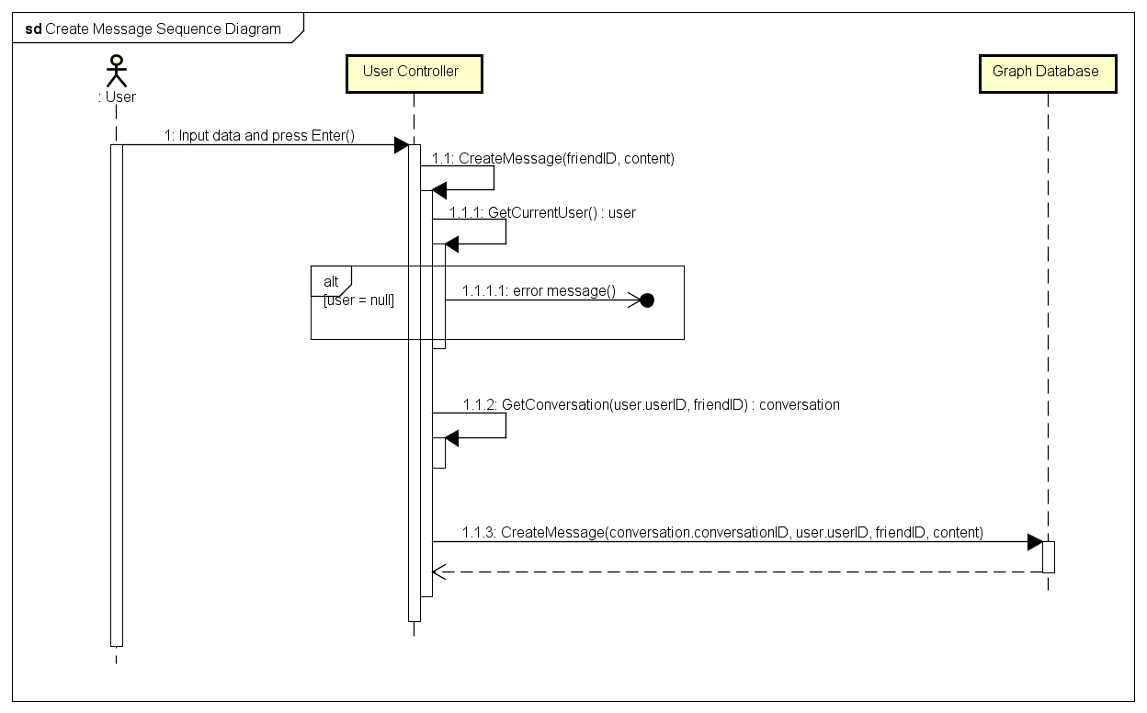

## Friend Management

### Class Diagram

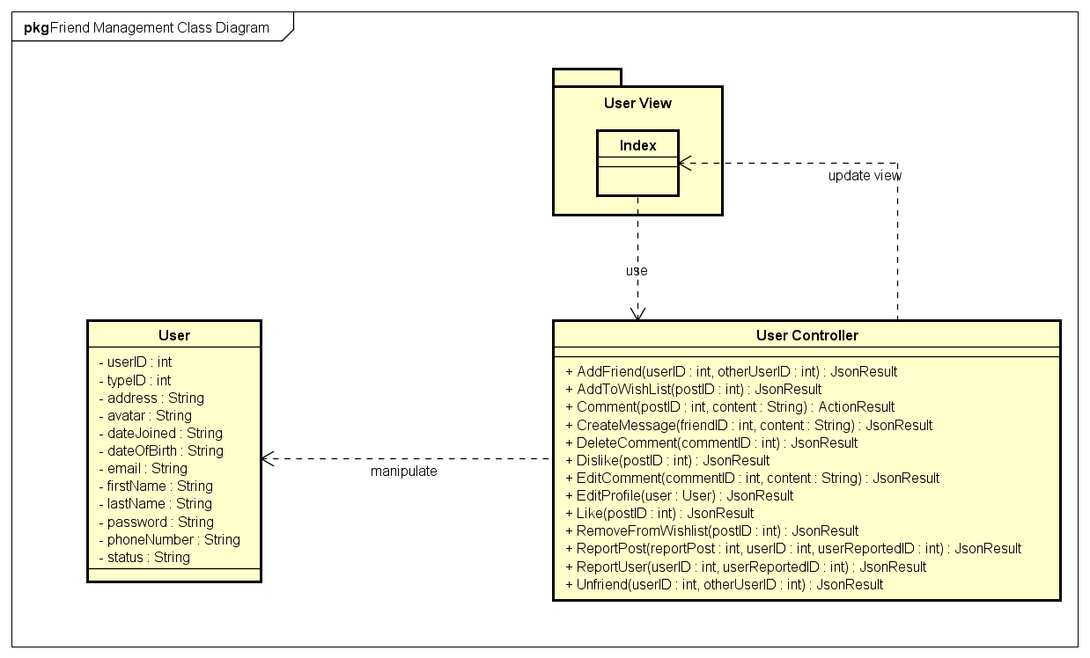

|  |  |  |
| --- | --- | --- |
| No. | Class Name | Description |
|  | User | Include method interact with Database |
|  | Index | Include method interact with Controller |
|  | User Controller | Include method interact with Model |

### User Class

#### Attributes

|  |  |  |  |  |  |
| --- | --- | --- | --- | --- | --- |
| No | Attributes | Type | Default | Note | Description |
|  | userID | int |  | public |  |
|  | typeID | int |  | public |  |
|  | address | String |  | public |  |
|  | avatar | String |  | public |  |
|  | dateJoined | String |  | public |  |
|  | dateOfBirth | String |  | public |  |
|  | email | String |  | public |  |
|  | firstName | String |  | public |  |
|  | lastName | String |  | public |  |
|  | password | String |  | public |  |
|  | phoneNumber | String |  | public |  |
|  | status | String |  | public |  |

#### Methods

|  |  |  |  |  |
| --- | --- | --- | --- | --- |
| No. | Method | Input | Return | Description |
|  |  |  |  |  |

### User Controller Class

#### Attributes

|  |  |  |  |  |  |
| --- | --- | --- | --- | --- | --- |
| No | Attributes | Type | Default | Note | Description |
|  |  |  |  |  |  |

#### Methods

|  |  |  |  |  |
| --- | --- | --- | --- | --- |
| No. | Method | Input | Return | Description |
|  | AddFriend | int, int | JsonResult | Add other users to friend list to get news, notification and messages |
|  | AddToWishlist | String | JsonResult | Add a post to wish list |
|  | Comment | int, String | ActionResult | Create a comment |
|  | CreateMessage | int, String | JsonResult | Send message to others |
|  | DeleteComment | int | JsonResult | Delete an owned comment |
|  | Dislike | int | JsonResult | Mark a post as dislike |
|  | EditComment | int, String | JsonResult | Edit content of an owned comment |
|  | EditProfile | user | JsonResult | Edit personal information |
|  | Like | int | JsonResult | Mark a post as liked |
|  | RemoveFromWishlist | int | JsonResult | Remove a post from wish list |
|  | ReportPost | int, int, int | JsonResult | Report a rule violation post |
|  | ReportUser | int, int | JsonResult | Report a rule violation user |
|  | Unfriend | int, int | JsonResult | Remove an user from friend list |

### Sequence Diagram

#### Add Friend

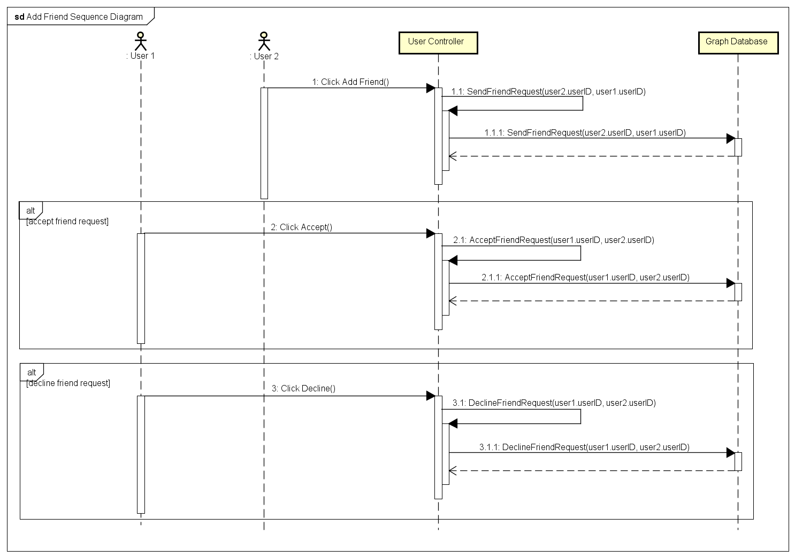

#### Unfriend

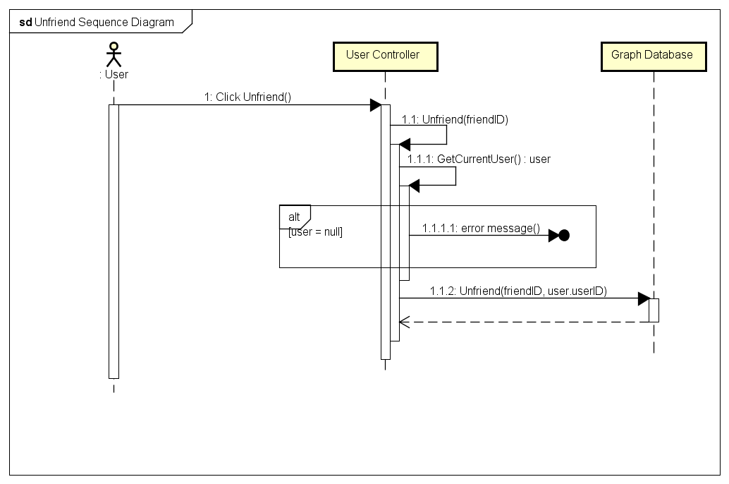

## Room (Undone)

## Account Management

### Class Diagram

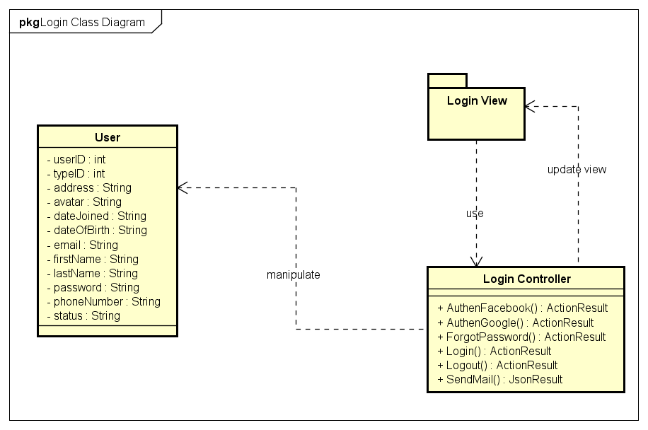

|  |  |  |
| --- | --- | --- |
| No. | Class Name | Description |
|  | User | Include method interact with Database |
|  | Login | Include method interact with Controller |
|  | Login Controller | Include method interact with Model |

### User Class

#### Attributes

|  |  |  |  |  |  |
| --- | --- | --- | --- | --- | --- |
| No | Attributes | Type | Default | Note | Description |
|  | userID | int |  | public |  |
|  | typeID | int |  | public |  |
|  | address | String |  | public |  |
|  | avatar | String |  | public |  |
|  | dateJoined | String |  | public |  |
|  | dateOfBirth | String |  | public |  |
|  | email | String |  | public |  |
|  | firstName | String |  | public |  |
|  | lastName | String |  | public |  |
|  | password | String |  | public |  |
|  | phoneNumber | String |  | public |  |
|  | status | String |  | public |  |

#### Methods

|  |  |  |  |  |
| --- | --- | --- | --- | --- |
| No. | Method | Input | Return | Description |
|  |  |  |  |  |

### Login Controller Class

#### Attributes

|  |  |  |  |  |  |
| --- | --- | --- | --- | --- | --- |
| No | Attributes | Type | Default | Note | Description |
|  |  |  |  |  |  |

#### Methods

|  |  |  |  |  |
| --- | --- | --- | --- | --- |
| No. | Method | Input | Return | Description |
|  | AuthenFacebook |  |  | User login with Facebok |
|  | AuthenGoogle |  |  | User login with Google+ |
|  | ForgotPassword |  |  | Set user’s password to a random string and send to user |
|  | Login |  |  | User login with registered account |
|  | Logout |  |  | User logout from FAP |
|  | SendMail |  |  | Send mail to user |

### Sequence Diagram

#### Login (Undone)

#### Logout

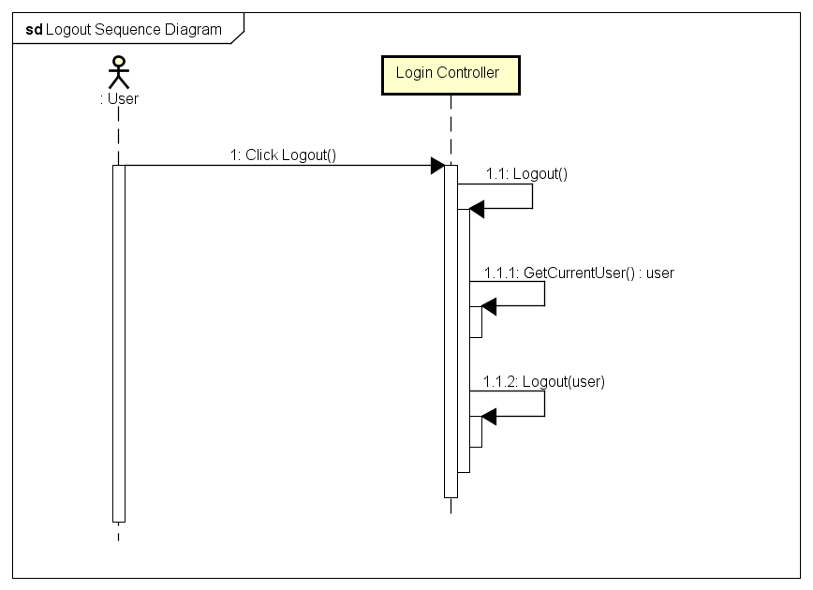

#### Register (Undone)

#### Edit Profile

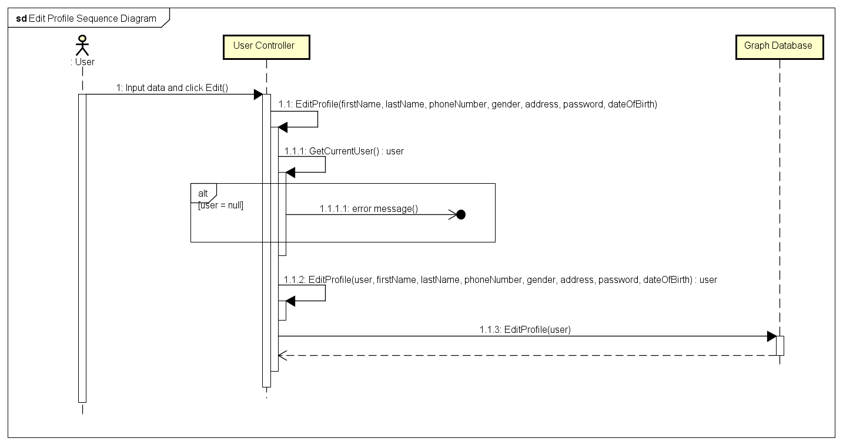

#### Forgot Password

